KISII UNIVERSITY
A PROJECT PROPOSAL ON
A Healthcare Web-Application For Chronic Disease Management
SUBMITTED IN PARTIAL FULFILLMENT OF THE REQUIREMENTS FOR THE DEGREE OF
BACHELOR OF SCIENCE IN COMPUTER SCIENCE
By
Abel Kiprotich Rono IN13/00026/20
Dennis Mwaura IN13/00008/20

Declaration
This proposal is our original work and has not been presented for approval in any other university.
Signature…………….. Date ………………
Abel kiprotich Rono
Signature……………..Date ……………
Dennis mwaura Kiaru
This proposal has been submitted for approval by
Signature……………… Date…………….
Dr Teresa Abuya

Dedication.
This work is dedicated to our families who have relentlessly thought us to rise and shine despite the many challenges we may have faced together. They have always encouraged us to never give up to just continue pushing.

Acknowledgement.
We highly appreciate the department of computing sciences for believing in our potential. We thank the head of department specifically for taking us through this unit of project development. This is a great motivation for us as we prepare for the outside world.
TABLE OF CONTENTS
ABSTRACT vii
CHAPTER ONE 1
1 INTRODUCTION 1
1.1 Background Information 1
1.2 Problem statement 2
1.3 Objectives of the study 2
1.3.1 Main Objectives 2
1.3.2 Specific objectives 2
1.4 Significance of the Study 2
1.5 Scope of the Study 2
CHAPTER TWO 4
2 LITERATURE REVIEW 4
2.1 INTRODUCTION 4
2.2 Previous approaches 4
2.3 Limitations of previous approaches 7
CHAPTER THREE 10
3 METHODOLOGY 10
3.1 Introduction 10
3.2 Project design. 10
3.2.1 Planning 10
3.2.2 Tool Requirements 10
3.2.3 General requirements. 11
3.3 Analysis and Design tools. 11
3.3.1 Implementation of tools 12
3.3.2 Development 12
3.3.3 Testing and validation 13
CHAPTER FOUR 14
4 Experimental results and discussions 14
4.1 Discussion 14
4.1.1 Home 14
4.1.2 Login 15
4.1.3 Appointments 15
4.1.4 Diagnosis page 16
4.1.5 Help desk. 16
4.2 Functional Requirements 17
4.3 Non-functional requirements 18
CHAPTER FIVE 18
5 Summary 18
5.1 Conclusions. 18
5.2 Recommendations. 18
References 20

ABSTRACT
Chronic disease are leading cause of disability and individual with this conditions are frequent users od healthcare. Our aim is to develop innovative solutions to prevent and manage chronic illness, which is critical given the increasing population and shifting healthcare towards value-based care.
Our project will create a platform for patients and healthcare providers to engage, offering crucial services for self-management of chronic conditions. With resources becoming scarce, this application will provide a solution to these problems, including remote monitoring to reduce hospitalization and simplify patient progress checks.
Patients with chronic conditions require constant consultations with doctors, especially concerning nutrition and medications. Our platform will facilitate remote patient-doctor engagement, providing essential healthcare advice.
As healthcare organization undergo major reorganizations to meet increasing demand for improved access, quality and cost-effectiveness, much of the necessary medical data is stored digitally. Web applications provide greater access and integration with the healthcare system, effectively meeting these challenges.

CHAPTER ONE

INTRODUCTION

Background Information

Technology has become increasingly popular for self-management of chronic diseases because of its high efficiency, accessibility, and cost-effectiveness. Sharon medlow et.al 2019 states that more adolescents with chronic physical illness are living into adulthood and require the development of proficient self-management skills to maintain optimal physical health as they transition into adult care services. It is often during this vulnerable transition period that deterioration in illness control is seen as a result of inadequate self-management skills and understanding of their chronic illness. Technology has provided an innovative opportunity to assist in improving the management of chronic conditions as young people transition to adult care services.
Remote monitoring became a major milestone during covid-19 pandemic due to measures put in place to deal with the situation, hospitals opted fully to use of remote monitoring applications to monitor patients. According to intelligent medicine (2022), technology played a bigger role during the covid-19 pandemic as patients experienced difficulties accessing medical services through face-to-face visits with the healthcare providers. This has led to widespread use of technology in the health sector.
Our project will help doctors track patients’ progress through remote monitoring as Maksingle et.al 2017 states that remote monitoring of patients targets several sub-groups of patients with chronic illnesses, including those who are monitored continuously which is inline with the aim of good health, which is the ability to support ordinary life as much as possible for all patients.
Shelly camilie Anchete et.al 2021 stated that technology has helped provide a more productive and patient-focused approach to patients who experience physical constraints and financial problems to attain good medical assistance. Our project anticipates achieving this by enabling online doctor-patient engagements. Doctors can provide assistance in terms of nutrition advice and medication intake.

According to Cossette et al 2018, dietary management is a necessary treatment strategy for chronic diseases. The use of these IT solutions should incorporate dietary management as the diet is a crucial part of managing chronic illnesses.

Problem statement
The prevalence of chronic diseases multi morbidity is an upward trend from the medical records show that there is a rise of 38.9 percent to 41.9 percent in the prevalence of chronic conditions (Gijsen et. al 2016).
This rising burden of chronic disease calls for innovative, cost effective and patient centered chronic disease management approaches. Despite the considerable progress made with technology appreciated in managing chronic illnesses management there are factors like remote monitoring, which involves doctor’s monitors the state of patients remotely which can be achieved in managing chronic diseases.
Our focus on remote patient monitoring by creating a platform where doctors have a chance to continuously monitor patient without meeting. Doctors will have a chance to monitor at their convenience. It will also be a beneficial to patients as they will be able to give necessary data at their own comfortability. Patient will be providing necessary details about their medications and current progress. They will then get reviews at an interval on their condition.

Objectives of the study

Main Objectives
Our main goal is to minimize symptoms, improve quality of life and prevent unnecessary hospitalization.

Specific objectives
1. To find out challenges of existing healthcare application.
2. To develop an online platform where patients can interact and share their experiences.
3. To test and validate the proposed application.

Significance of the Study
Our aim of this research is to reach a widest population as possible regardless of the compatibility of their devices.
Our project is to bring a new achievement to healthcare providers to monitor the growing population and provide necessary advice. This project also, will be beneficial to wide range of users as they can access the application with any device at their disposal, get real-time reviews from health providers thus maintaining a healthy life.

Scope of the Study
We discovered that there are many applications for chronic disease management but they are not reliable. Patients need real-time data for their well-being. Also, healthcare providers need real-time data for monitoring their patients and check their progress through remote consultations.
Our goal is to reach a widest possible audience with mobile-friendly content without being specific on a chronic disease.
Our goal is for the users to get services instantly rather than downloading the application from marketplaces before the content which can be viewed as a significant barrier between initial
engagement and action.

CHAPTER TWO

LITERATURE REVIEW

INTRODUCTION
This chapter provides a review of existing literature on chronic disease management and the use of technology in healthcare. It will discuss current challenges and the gaps in chronic disease management as well as the benefits of using web-based solutions for this purpose. Additionally, it would review existing web applications for chronic disease management including their features and effectiveness and identity areas for improvements. Chronic diseases have become a major health concern worldwide, accounting for over 60% of global deaths(world health organization,2021). These diseases, such as diabetes ,are often lifelong and require constant management. Self-management of chronic disease becomes increasingly popular due to its high efficiency, accessibility and cost effectivesness. In the literature review , we will explore the current state of technology for self-management of chronic diseases with a focus on remote monitoring and remote consultations.

Previous approaches
Chronic disease being a major concern in the recent years have brought experts to come up with ways to curb the surge if the condition and manage it. As the world becoming more inclined to technology such as web application field have planned an important part in the day to day life for people as many people recently spend time more on computers, phones and tablets . According to Muhammad sarwar et al(2013), on the impact of smartphones to the society it states that the adoption of smartphones has been tremendous in mainstream consumer markets all over the world. Surveys show that around 42% of mobile in US use smartphone’s along with 44% of mobile users in 5 major countries of European union. In addition the mobile usage on mobile including web browsers have increase surpassing over 50% in markets.
mdiabetes: This is a mobile-based platform that provides diabetes education, self-management tools and telemedicine services to patients in Kenya. The platform includes a symptom tracker, medication reminders and the ability to connect with healthcare providers for remote consultations.
Toto health: This is a mobile and web-based platform that provides maternal and child health services, including education on chronic conditions such as hypertension, diabetes and malnutrition. The platform includes a symptom tracker, medication reminders and the ability to connect with healthcare providers and remote consultations.
Health wallet: This is a e-health platform that allows patients to store and share their health information with healthcare providers. The platform also includes a symptom tracker, medication reminders and the ability to connect with healthcare providers for remote consultations.
The summary below shows that many applications were developed or updated in the year 2020 where there was an outbreak of corona virus. The use of mobile phones was the best solution to deal with the spread of COVID-19 by reducing crowding in hospitals and other public places. The use of technology has been adapted since.
Application name | Developer/Country | Purpose
Mawid App | Ministry of health Saudi Arabia | Appointment system.
Tabaud App | Saudi Arabia | Developed to achieve health and safety goals.
Tawakkalna | Ministry of health Saudi Arabia | Facilitate emergency movements of people during lockdown and curfew and provide information of information about COVID-19.
Sehha App | Saudi Arabia | e-consultations through audio and video calls
Aarogya | Government of India | Tracking COVID-19 outbreak
TraceTogether app | Singapore government | Tracking COVID-19 outbreak
COVID safe app | Australian department of health | Tracking COVID-19 outbreak
The rapid use of mobile technology is evolving. Many of these application have not pass through health care system sleurs et al 2019 found that 18 percent of the applications have passed through the healthcare providers and only 3 percent of the applications reached 7 out of score 10.
COVID-19 was an eye opener for adopting technology in fighting and containing the spread of this deadly virus. Interactions between people was greatly affected, therefore, internet of things devices were developed to track down susceptible cases (Naseem et al 2022).
Using technology in the delivery of medicine. Pratap et al 2019, the application of nanomedicines is increasingly rapidly with the promise of targeted and efficient drug delivery. Nanomedicines address the shortcomings of conventional therapy, as evidenced by several preclinical and clinical –investigations indicating site-specific drug delivery, reduce side effects and better the treatment outcome.
Pharmacist are the third largest medical professionals after nurses and doctors, they play and important role in the provision of drugs to patients. They contribute to the safe, effective and efficient use of drugs (Mossialos et. al 2015). Transforming their role is one of the ways of managing these conditions and developing a framework example for data collection will be of great advantage.
Through the evolving of tracking devices becoming smaller and cheaper has offered the an opportunity in patient interaction and engagements as these devices can provide data directly from patients (Chiauzzi et al 2015). This is beneficial as patients receives personalized care depending on the data collected.
Using mobile applications in self-management for long term conditions. According to Whitehead et.al 2016, they assessed the effectiveness of mobile applications on diabetes and cardiovascular diseases and the outcome clinical safe, they proved that self-management reduces symptoms.
Monitoring through text messages. A study by Thakar et.al 2016, traditional methods are time consuming on of the ways of using the readily available devices for messaging. randomized clinical trials on medical adherence by adults.
Author | Area of study | Conclusions
Sleurs et al 2019 | Evolving of healthcare applications and it use in accordance to the healthcare providers | Few applications have been developed jointly with doctors and with lower feed back
Naseem et al 2022 | Using Internet of things ins tracking down COVID 19 suspects | It has been a great advantage in using internet of things in compacting the spread of corona virus
Pratap et al  2019 | Use of technology in delivery of medicines to the patients | Additional clinical trials must come from all over the world
Mossialos et. al  2016 | Using technology in transforming data collection and delivery of drugs by pharmacist | Integrating pharmacist to the healthcare system and equipping pharmacist with patient centered roles.
Chiauzzi  Et al 2015 | Using wearable devices for tracking activity of the patients | Integrating wearable devices into healthcare system for improving patient medications and tracking each activity for personalized treatments.
Whitehead et.al 2016 | Using mobile applications for managing long terms symptoms | Application plays an important role in managing symptoms for chronic conditions
Thakkar et al 2016 | Adherence of medications by adults | Medical intervention through text messaging showed a positive effect. Future intervention in improving success of text messaging intervention.

Limitations of previous approaches
Adoption of mobile apps requires a strong proposition. Mobile health apps are difficult to sell to patients, introducing additional complexity for how to fund the provision and maintenance of these technologies. With relatively few patients willing to pay for these digital tools, healthcare organization providers (health systems or primary care practices) and payers(self-insured employers or health insurers) often assume the costs. To date, little evidence demonstrates improved health outcomes or lowered costs that can justify the costs of developments and adoption (Hong et.al 2020).
Although these applications have brought tremendous support to healthcare systems, they have setbacks. Acqusition of real-time data has been a challenge, as mobile applications do not guarantee real-time data and at times require updating, which is viewed as a significant barrier to access healthcare services (Talboom-Kamp et.al 2018). Mobile apps are less flexible in updating content, therefore, at times users don’t get information due to system upgrading ( sohn et al 2018). Due to rapid change in technology in terms of scaling and security features, mobile applications require frequent updates, which possess a risk because when the application is outdated, some of the features seize to function. This implies that the user has to be offline thus hindering service delivery (jiang et.al 2018).
According to Delveninsight 2021 on the disadvantages of mobile health applications, its states that the information and advice provided by healthcare apps are also a concern because different apps use different methods and tools to analyze data. In some cases, the data varies compared to others. This case data integrity is undermined.
Chronic diseases affect different age groups and most people affected by these illnesses are old, making it more critical. Data should be should be accurate, otherwise, the health of these patients will be subjected to medical risks. As Zarour et.al 2020 states that data integrity has become a persistent problem recently and a main concern in health sector.
Lack of trust in how traditional medical devices are being appraised and reimbursement. According Rebecca tooher et al (2019) there are concerns lack of clarity on which healthcare system was used to determining the quality of the healthcare apps.

Recently there are a lot of mobile applications for healthcare, the quality of this apps is becoming increasingly important issue. According to a study conducted by Hammand Khalid et.al 2014, there are a lot of complains about some mobile-application these are; the app crashes and ethical issues among others.
Misinformation and inaccuracy. Many healthcare applications relay inaccurate or misinform the users thus leading to misdiagnosis and trauma. This affects majorly users who have rely solely to the applications or the application is the only option at the time (El-Gayar et.al 2013)
Regulation policies. There are many healthcare applications that did not undergo rigorous testing for its safety to the users. The effects are catastrophic to the users.
Reduced interaction between the applications and the user friendly application improve the engagement rates of the application with the patients as patients shy away from applications that are not friendly (Sezgin et.al 2017).
Our primary benefit is to improve patients and healthcare providers engagements and patients to self-management their conditions at their comfort of their homes. With some of the health care apps being expensive to patients. We created a free application which can be just accessed without paying any cost since some apps are premium. Our system will be simple for patients and doctors to navigate and reliable.
One of the benefits for our application is that it gives healthcare ability to collect and analyze from a large group of patients which they will then use to make inform treatments decisions and improve disease management (Kim et al2011).
Our application we intended to develop an improve system which is user centered, the application will focus on the users and their needs in each part of the application. According to the study done by iman dianat et al (2019) suggested that the website should focus more on the web design attributes (particularly web layout and structure), regardless of the personal characteristics of their users, to improve the usability and user satisfaction of websites. This is important because the end users will be involved thus increasing the likelihood of sustainable engagement.
Developing a more interactive and web application. A study done by Samantha a adams (2010) stated that an interactive and collaborative web applications provide new opportunities for health sector for reaching patients and other consumers by facilitating sharing, retrieval and information creation and also provide a wealth of information to healthcare providers in their medical encounters.
To improve data integrity, we created a feature for data collection. Where patients fill data in a form this will enhance correctness of the data collected. A study by Bosun tijani et.al (2021) stated the most of inaccurate data occurs at data collection sections.
Developing a web application with a reminder feature. Lack of reminders are common and costly which contribute to poor medical outcomes (Dayer et.al 2013). Nonadherence also degrades healthcare resources so developing application to address this issue proves to be the a better solution.
According to Greenhalgh et.al 2015, doctor patient engangement through healthcare applications have improve the patient’s outcomes. Patients who have regular communication with their doctors are mostly likely to be satisfied with their care and are more likely to recommend their doctors to other.
Efficient doctor-patient engagement. The applications is able to bridge the gap between the patient and the doctor therefore, frequent engagements reduces time used for visiting hospitals and any emergency can be dealt with immediately (zheng et.al 2018)
Remote monitoring has greatly improve medications adherence. Reminders and follow ups have been of great advantage to doctors in their decision making and trust between them and the patients leading to better health outcomes. Frequent doctor patient interaction is vital and common in remote monitoring. Chronic diseases requires a lot of attention and resources that once not adhered to can be fatal, therefore, communication is one of the main important aspect. According to Noordman et.al 2019, patient-centred communication and emphaty are key from patient centred care and relational skills between the physician and the patient.

CHAPTER THREE

METHODOLOGY

Introduction
In this chapter we focus on step-by-step methods on how we intend to achieve our system objectives.
Implementation of information technology in management of chronic illness has be a great achievements to healthcare providers and patients. Since these conditions require a lot of care and with the growing population making it hard for healthcare sector to achieve it’s goal due to scarcity of healthcare facilities. Health care opted for home based care with the growing technology, it has made it successful thus revolutionize the health sector in service delivery and minimizing mortality rate for people living with chronic illnesses.

Project design.
We used incremental software development lifecycle, the project development was divided into multiple parts. We designed, implemented and tested our system incrementally until it was finished. This case it helped us ease the load of testing the whole project which at times contain multiple errors if tested at once. This methodology also helped us a lot in terms of consultations and additions of other functionalities to our system.

Planning
We made consultations with support personnel to direct us on the right steps to take. We used Brackets, Visual Studio and MySQL in XAMPP for our system’s development. They will help us in integrating the different programming languages to come up with our system. Languages are: Python Django framework, JavaScript, HTML and Cascading Stylesheets.

Tool Requirements
We need the following for our system: a database (in this case, we used MySQL in XAMPP), Brackets and Visual Studio SDK. These helped us develop our system with greater performance capabilities.
Task | Tool used for the task | SDK
Database creation | MySQL | XAMPP
Connection to the database | Python | PyCharm/Brackets
Dynamic and interactivity of the page | Django | Visual Studio
General design and makeup | HTML CSS and JavaScript | PyCharm/Brackets
Table 1.0. Indicates the tools used for the software Development.

General requirements.
User registration – The new user accesses the sign-up page and gives their credentials. The credentials are saved in the database and the user is prompted to login. If the credentials match the user access the website.

Analysis and Design tools.
Flow chart for users authetication. The authentication comsists of two fields the user is prompted to enter the email and password so that they can access their dashboard. If incorrect credentilas are enter the user is prompted to repeat the process.

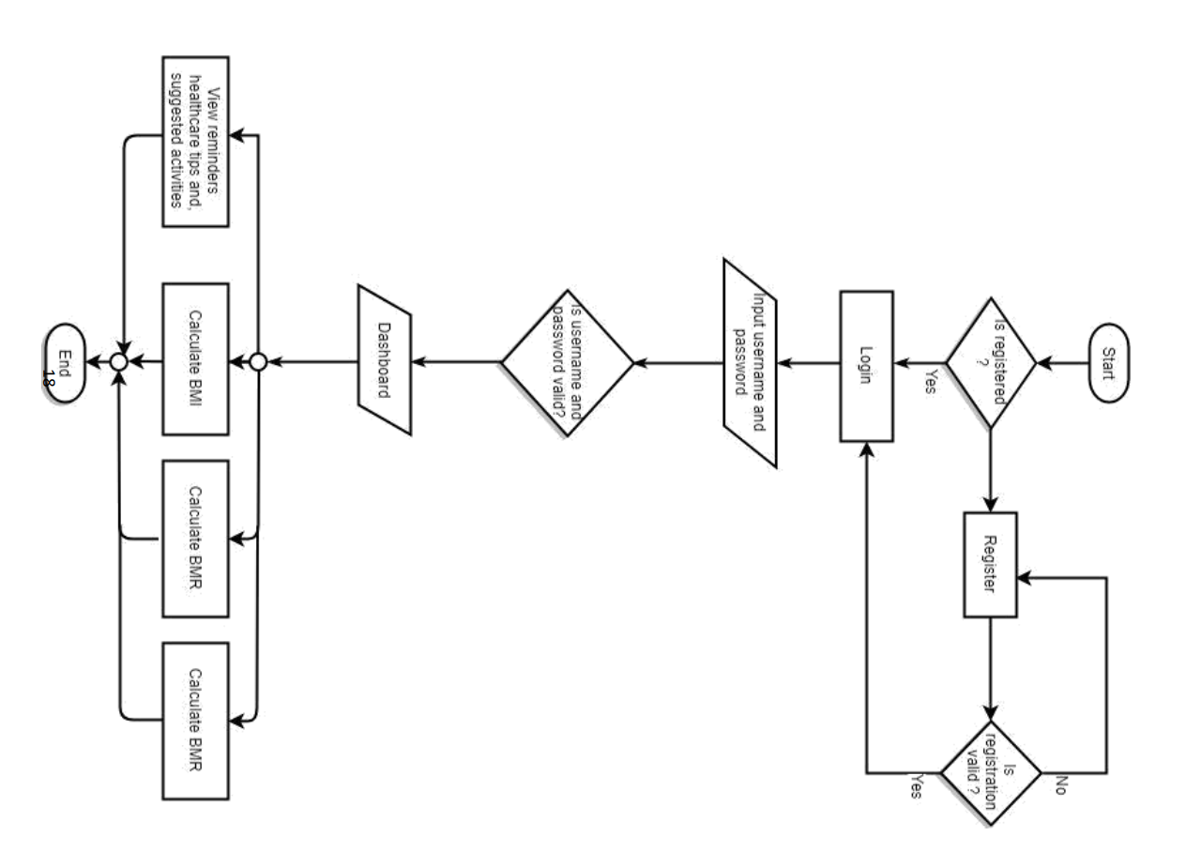

Use case diagram: it depicts how users interact with the system.
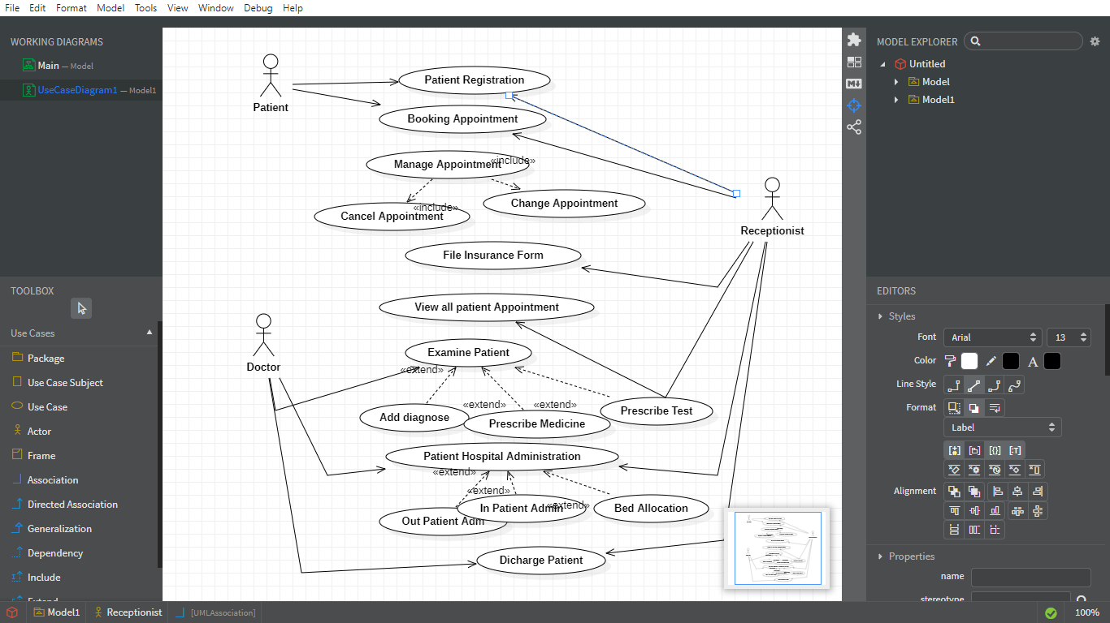
State diagram for doctor patient appointments
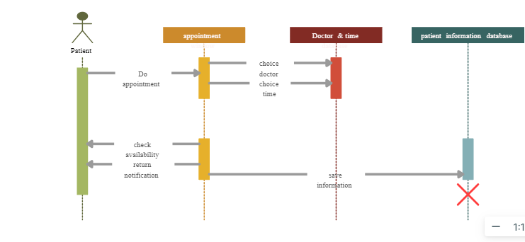

Implementation of tools
We first develop the front-end of the website using HTML and CSS. We the used python as our server-side scripting language to build the backend and flask framework for built in support for web development tasks. Our relational data base for storing data for the users of the application, was implemented using replit database.

Development
After writing our codes, we integrated them to come up with a complete system. We availed it for testing and made it ready to be used by the customers for production.
First, we developed the website using HTML, CSS, JavaScript and Flask. We then created database to store doctors and patients’ information farm. Lastly Python code was written to connect the database dependent pages to the database as shown in the flow below:

Time to time maintenance will be done to solve any post-production issue that may arise.

Testing and validation
Since we used Flask framework, testing was not necessary as it comes with a built-in testing framework that supports integration testing. It provides a set of test client tools that allows simulation of requests and responses and to test the interaction between the frontend and backend.

CHAPTER FOUR

Experimental results and discussions
This chapter analyses the results obtained from the previous chapters and shows the implementation of the proposal framework.
Healthcare is the fundamentals sector for the survival of the human race and health starts from and individual.
Using technology in health sector has provide an upper hand in managing a healthy population. Chronic disease being the major issue in health technology innovations has played a bigger part in managing these conditions and preventing unnecessary loose of life.

Discussion

Home
Home page for our website has about links on the navigation, signup and login and contact info and the body we have clinic and specialties to handle different diseases.

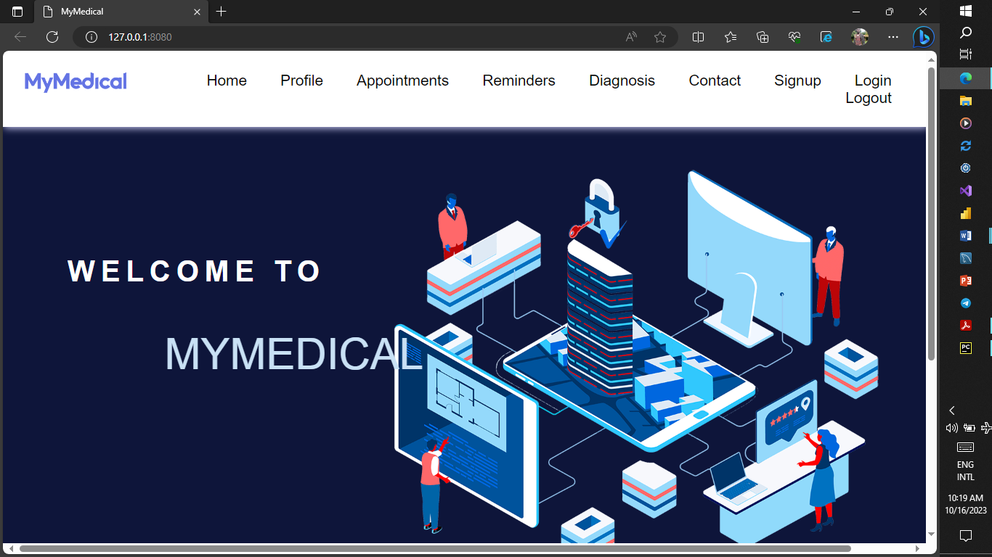

Login

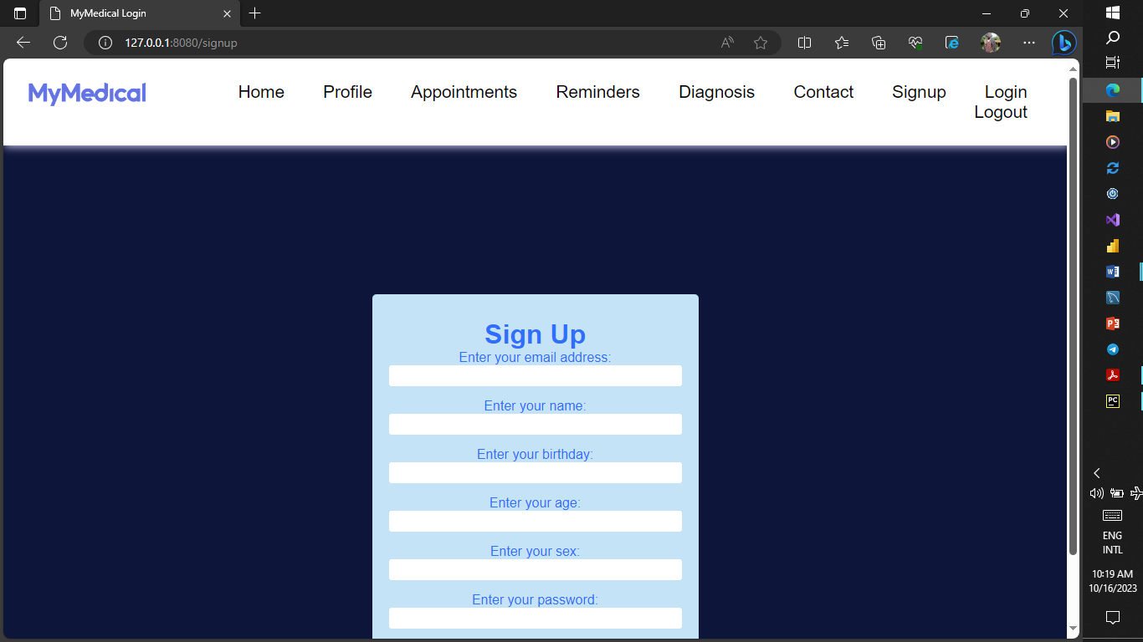
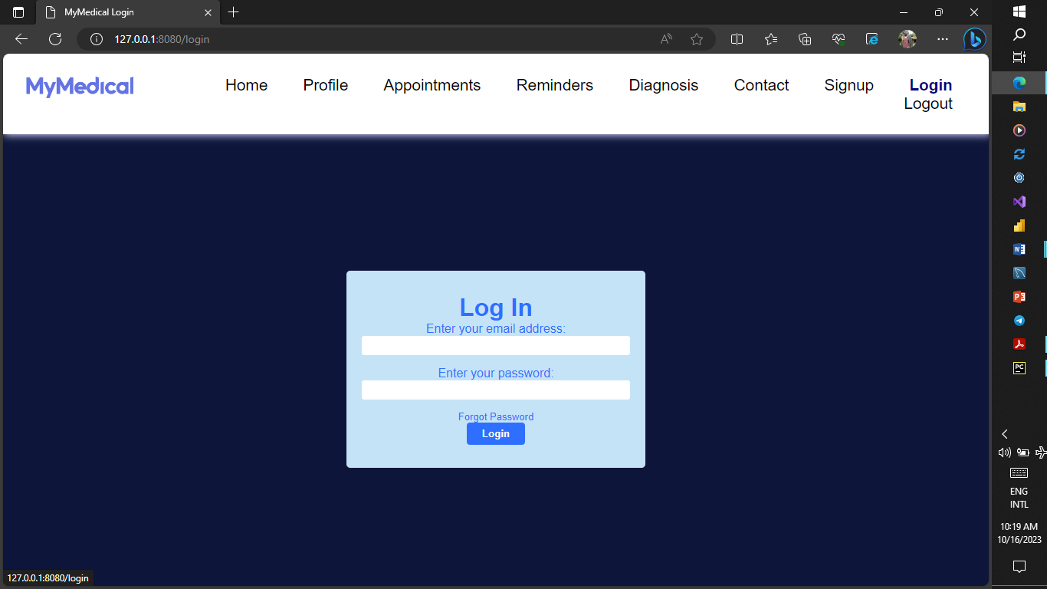

Appointments

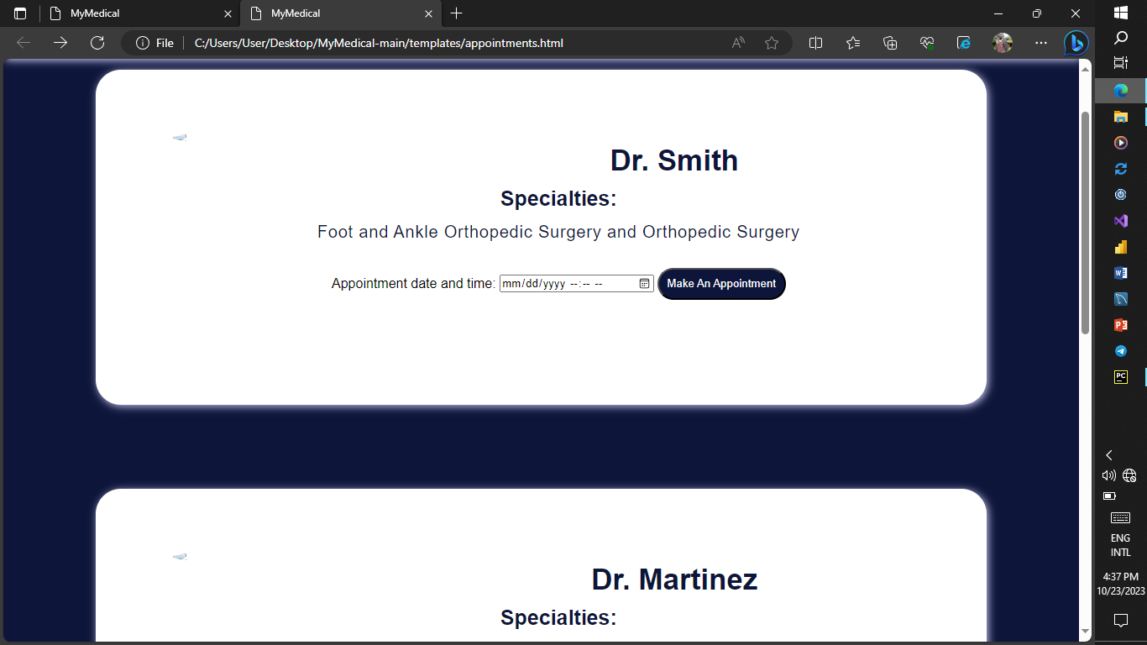

Diagnosis page

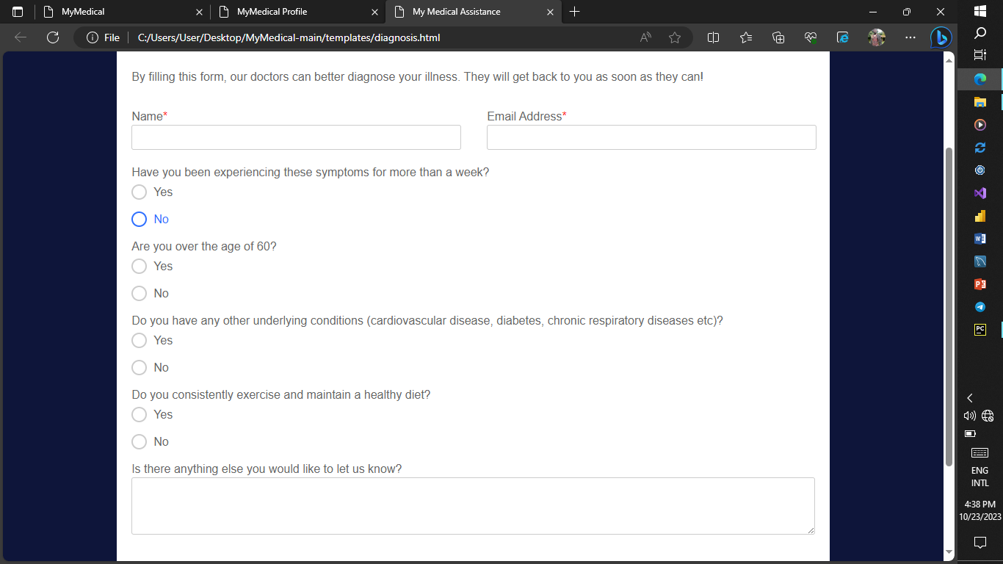

Help desk.
In this page the user can ask or consult anything or problem her or she encountered with the application.
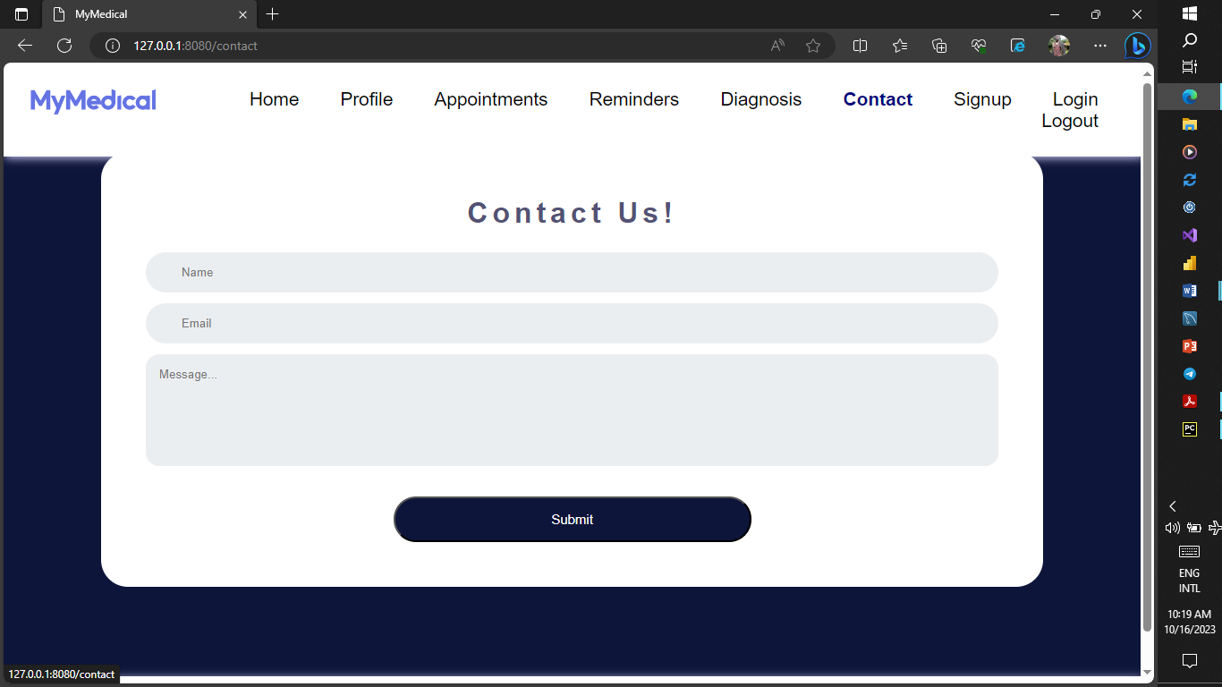

Functional Requirements
They are associated with specific functions task or behavior the system support
Functional requirement | Issue addressed
User authentication | The system ensured that only authorized users can access the website through login
Patient profile management | The application allowed healthcare providers  To create and manage the patient profiles that include relevant health information.
Appointment scheduling | The application allowed healthcare providers to schedule appointments with patients and send automatic reminders to patients about upcoming appointments.
Patient communication | The application allowed patient to communicate among each other and also with the doctors through messaging.

Non-functional requirements
Performance: the application is able to handle a large number of users and the transactions without experiencing performance issues. This include; minimal downtime.
Usability: This application is easy to use and navigate with a simple and intuitive that does not require extensive training.
Security. Our application have strong security measures in place to protect patient data this including secure login systems and access control.
Availability: This application is available to users extensively, users can access the systems any time the want since it has minimal downtime or systems failures.

CHAPTER FIVE

Summary
This project proposal outlines the development of a web application for chronic disease management. The application will aim to provide patients with a convenient and accessible way to manage their illnesses as well as give healthcare providers with a tool to monitor patients and provide better care. The propose solution provides length of features such are online doctors appointment and remote monitoring of patients all designed to help patients manage their conditions effectively.

Conclusions.
The development of web application for chronic disease management is critical need in the health industry. Chronic disease is a burden to patient’s healthcare providers abd healthcare system as a whole. A comprehensive web application can help patients manage their conditions effectively, leading to a better outcome and reduce costs.

Recommendations.
To successfully develop and implement the proposal web applications for chronic disease management recommends the following:
- Ensure user centred design: The web application should be designed with the needs and preferences of users in mind to ensure usability and adoption.
- Address data privacy and security: The web application should adhere to data privacy regulations and include appropriate security measures to protect patient’s personal health information.
- Consider interoperability: the web application should be designed to allow for interoperability with other healthcare systems and technologies to ensure seamless data exchange.
- Provide user training and support. The web application should include user training and support to ensure that patients and healthcare providers can use the application effectively.
By considering these recommendations, the proposed web application for chronic disease management can be developed and implemented successfully, leading to improved health outcomes for patients and better for healthcare providers.

References

Lakim p Malasingle, Neem Razman , Kehsave. 2017. Remote Monitoring comphesive Study.
vol 35. Page 65.

Shelly Ancheta, Claire Francisco. 2021. Nucare a Framework for mobile and web application for online consultations. vol 3

Cossette Faikih, El Khoury, Mirey, Roud JG Halfers, Rif Crutzen. 2019.
Effects of dietary mobile application on nutritional outcomes in adults with chronic diseases asystramatic review and meta-analysis

Mohammad Zarour, Mamsouh, Alenzi, Jamal Ansari, Kumar Panday, Nasoud Ahmad, Rajeev Kumar, Alk Agrawal 2021. Ensuring data integrity in Digital health. Vol 98.

Sharom medlow, Jane Ho, Katherine Steinbeck 2019. Mobile and Web application that support Self-management and transition in young people living with chronic illness.

Young Hon Kim 2013. Study of mobile user engagement.
Volume 39 page 56

Harold Goldberg, Jame Ralton, Irish B Hirsh 2013. Wen based Colaborative Care for type 2 diabetes: A pilot randomized trial. https://doi.org/10.2337/dc08-1220

Greenhalgh, T,Pocter, R, Wherton, J SugarHood, P Shaw 2015. The organizing vision for telehealth and telecare discourse analysis. BMJ Open 5(2)

Zheng H , Qi X Huang Y 2018. Health apps for patient with chronic disease and health professionals: Scoping review. Journal of Nursing Management 26(6), 707-720.

El-gayar, o., Timsina., P., Nawar, N Eid, W 2013. Mobile applications for diabetes self-management : Status and potential. Journal of diabetes science and technology 7(1) 247

Xu, W ., Liu, Y Mao 2018. The impact of mobile health applications on medication adherences systematic review. Journal of diabetes and technology 12(4) 810-816.

Blobel, B yang 2018. The role of axiomatically-Rich Ontologies in Transforming medical to knowledge. Page 51.

Talya Holmes 2021. Pros and cons of mobile health apps.
https://www.dignityhealth.org/articles/the-pros-and-cons-of-mobile-health-apps

Rebecca Tooher, Magdelena Ruth, Tracy Merlin 2019. Ecaluation of Mobile health Application: is regulatory policy up to the challenge? Volume 35 issue 4

Elias Mossialos, Emilie Courtlin, Huseyin Naci, Shalom Benrimoj, Marcel Bouvy,Karen Farris, Peter Noyce, Ingrid Sketris. 2015. From retailers to health care providers: Transforming the role of community pharmacists in Chronic disease management. Volume 119 issue 5. page 628-639.

Emil Chiauzzi, Carlos Rodarte, Pronabesh DasMahapartra 2015. Patient-centred activity monitoring in self-management of chronic health conditions. Article number 77.

Lindsey Dayer Pharmd, Seth HeldenBrand PharmD, Pual Anderson, Paul o. Gubbins, Bradley C martin 2021. Smartphone medication adherence apps: Potential benefits to patients and providers. Volume 53, issue 2.

J Noordman, B.post A..A.A van dartel, J.M.A Slits, T.C olde Hartman 2019. Training residents in Patient-centred communication and empathy: evaluation frompatients, observers and residents. Article 128.

Hammad Khalid, Emad Shirab, Meiyappa Nagappan, Ahmed Hajj 2014.
What do mobile app users complain about. ieeexplore.ieee.org.

